What will we be learning?  Unit 11 – Physical activity for specific groups | Why this? Why now?  This unit is delivered in Year 13 in the Spring and Summer term alongside Unit 8. It is the smallest of the units studied in this course and is recommended by OCR to be taught at the end of the course. | Key Words:  Target groups  Antenatal  Postnatal  Medical referral  Provision  Campaigns  Physiological  Psychological  Sociological  Barriers  Exercise referral  Contraindications
What will we learn?
- LO1 – Know about the provision of physical activity for specific groups
- LO2 – Know the benefits of and barriers to participating in physical activity for specific groups
- LO3 – Know the exercise referral process
- LO4 – Be able to plan physical activity sessions for specific groups
What opportunities are there for wider study?
Careers/degree courses
- Sports science
- Physiotherapy
- PE teacher
Further reading:
Strategies to improve participation - Social groupings and participation in sport - OCR - GCSE Physical Education Revision - OCR - BBC Bitesize
Getting Dorset Active | Active Dorset
How do exercise referral schemes work? - MotleyHealth®
How will I be assessed?
- Teacher set assignments on Teams
CAM TECH – SPORT
UNIT 11

LO1 – KNOW ABOUT THE PROVISION OF PHYSICAL ACTIVITY FOR SPECIFIC GROUPS  - How and why specific groups are identified as being target groups:  - Antenatal & postnatal  - People with disabilities  - Older adults  - Children & Adolescents  - Young women & girls  - Specific cultural groups  - Medical referral  - Provision  - Campaigns &/or agendas which target specific groups | 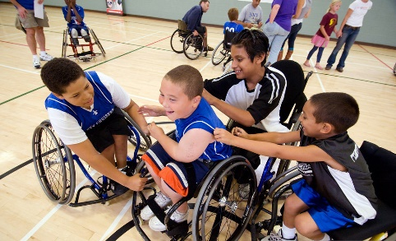
LO2 – KNOW THE BENEFITS OF & BARRIERS IN PARTICIPATING IN PHYSICAL ACTIVITY FOR SPECIFIC GROUPS  - Physiological benefits of participating in regular physical activity  - Psychological benefits of participating in regular physical activity  - Sociological benefits of participating in regular physical activity | 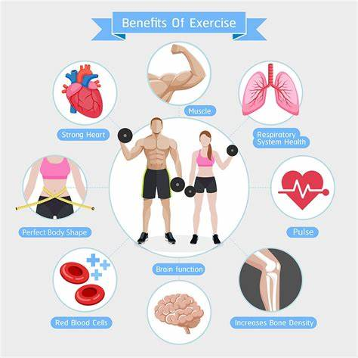
LO3 – KNOW THE EXERCOSE REFERRAL PROCESS  - Exercise referral process:  - Purpose  - Screening procedures  - Referral professionals  - Reasons for referral  - Recommended guidelines | 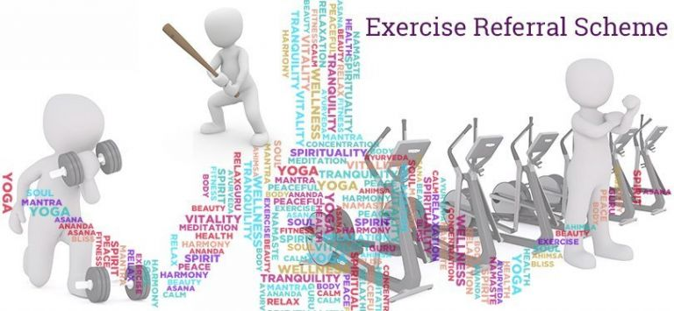
LO4 – BE ABLE TO PLAN PHYSICAL ACTIVITY SESSIONS FOR SPECIFIC GROUPS  - Planning considerations:  - Aims of session  - Timing and sequencing of activities  - Contraindications  - Health and safety  - Communication methods & techniques  - Ability level  - Resources  - Medical history  - Initial screening  - Informed consent  - Risks associated with specific groups | 